MyCli支持自动补全和语法高亮 MySQL 客户端

# 简介

MyCli 是一个 MySQL 命令行工具，支持自动补全和语法高亮。也可用于 MariaDB 和 Percona。

截图展示

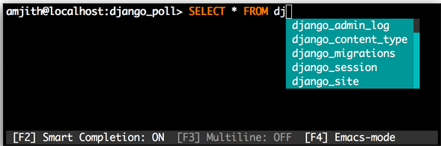

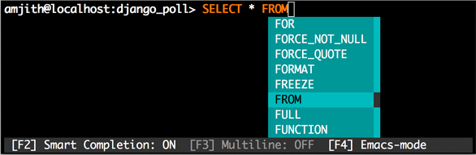

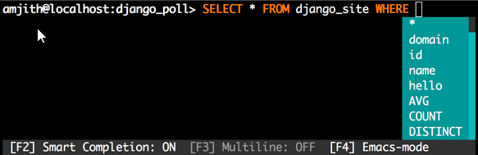

动图展示



# Quick Start

如果你已会安装 Python 包，那就简单了：

$ pip install mycli

如果你是在 OS X 平台，那就用 homebrew：

$ brew install mycli

## 用例:

|  |
| --- |
| $ mycli --help  Usage: mycli [OPTIONS] [DATABASE]    Options:  -h, --host TEXT Host address of the database.  -P, --port TEXT Port number to use for connection. Honors  $MYSQL_TCP_PORT  -u, --user TEXT User name to connect to the database.  -S, --socket TEXT The socket file to use for connection.  -p, --password Force password prompt.  --pass TEXT Password to connect to the database  -v, --version Version of mycli.  -D, --database TEXT Database to use.  -R, --prompt TEXT Prompt format (Default: "\t \u@\h:\d&gt; ")  -l, --logfile FILENAME Log every query and its results to a file.  --help Show this message and exit. |

## 示例

|  |
| --- |
| $ mycli local_database  $ mycli -h localhost -u root app_db  $ mycli mysql://amjith@localhost:3306/django_poll |